Question 1

What is the optimal value of alpha for ridge and lasso regression? What will be the changes in the model if you choose double the value of alpha for both ridge and lasso? What will be the most important predictor variables after the change is implemented?

Answer: Optimal value of alpha for lasso and ridge are 0.0001 and 0.9 respectively. If we increase the alpha the accuracy of the model starts dropping gradually. It might increase a bit till the optimal hyper parameter value but the accuracy will decrease with the increase in alpha.

Features selected by Ridge:

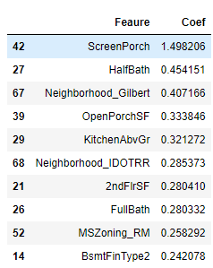

Features selected by LASSO:

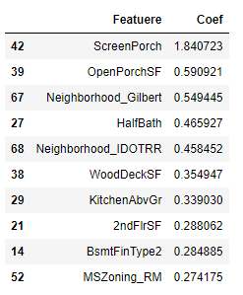

**Question 2**

You have determined the optimal value of lambda for ridge and lasso regression during the assignment. Now, which one will you choose to apply and why?

**Answer**: Since LASSO is helping in removing some of the features by making co-efficient as zero, I will go for LASSO. Lesser the features simpler will be our model.

**Question 3**

After building the model, you realized that the five most important predictor variables in the lasso model are not available in the incoming data. You will now have to create another model excluding the five most important predictor variables. Which are the five most important predictor variables now?

**Answer**: Five best features are

**HalfBath** : Half baths above grade

**LowQualFinSF** : Low quality finished square feet (all floors)

**MiscVal** : $ Value of miscellaneous feature

**BsmtHalfBath** : Basement half bathrooms

**BsmtFullBath** : Basement full bathrooms

**Question 4**

How can you make sure that a model is robust and generalisable? What are the implications of the same for the accuracy of the model and why?

**Answer**: Adding regularization make sure model is generalized version and is not overfitted on data. Regularization may lead to bit decrease in accuracy but having a model that fits well on unseen data is more important. Also, lot depends on which parameter – sensitivity, precision or specificity is better suited to the used case. We need to evaluate model not only on accuracy but also on other parameters.